**Understand with Example**

This example illustrates how to create a search application in the PHP. To access the records from table 'user' in the database we create a table user. The select statement fetches the records from table 'user'.

**Table: user**

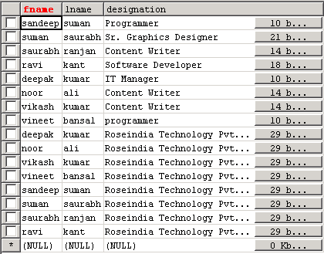

In this example we create a text box where user put his/her search term and choose a option from select box. When user submit his/her query then we select all list from database table where the query stream involve.

**$find = strtoupper($find):** The PHP strtoupper ( ) Function convert the search text into upper case.

**$find = strip_tags($find) :** The string functions is used to manipulate strings.

**$find = trim ($find) :** The PHP trim() function returns a string without leading and trailing spaces.

**Source Code of searchForm.php**

<h2>Search Form</h2>  
  
<form name="search" method="post" action="<?=$PHP_SELF?>">  
  Seach for: <input type="text" name="find" /> in  
  <Select NAME="field">  
  <Option VALUE="fname">First Name</option>  
  <Option VALUE="lname">Last Name</option>  
  <Option VALUE="designation">Designation</option>  
  </Select>  
  
  <input type="hidden" name="searching" value="yes" />  
  <input type="submit" name="search" value="Search" />  
</form>  
  
<?php  
  if ($searching =="yes"){  
  echo "<h3>Search Results</h3><p>";  
  if ($find == ""){  
  echo "<p>Please Enter a search term";  
  exit;  
  }  
    
  mysql_connect("localhost", "root", "root") or die(mysql_error());  
  mysql_select_db("test") or die(mysql_error());  
  $find = strtoupper($find);  
  $find = strip_tags($find);  
  $find = trim ($find);  
  
  $query = mysql_query("SELECT * FROM user WHERE upper($field) LIKE'%$find%'");  
  while($result = mysql_fetch_array($query)){  
  echo $result['fname'];  
  echo " ";  
  echo $result['lname'];  
  echo "<br>";  
  echo $result['designation'];  
  echo "<br>";  
  echo "<br>";  
  }  
  
  $matches=mysql_num_rows($query);  
  if ($matches == 0){  
  echo "Sorry, we can not find an entry to match your query<br><br>";  
  }  
  
  echo "<b>Searched For:</b> " .$find;  
  }  
?>